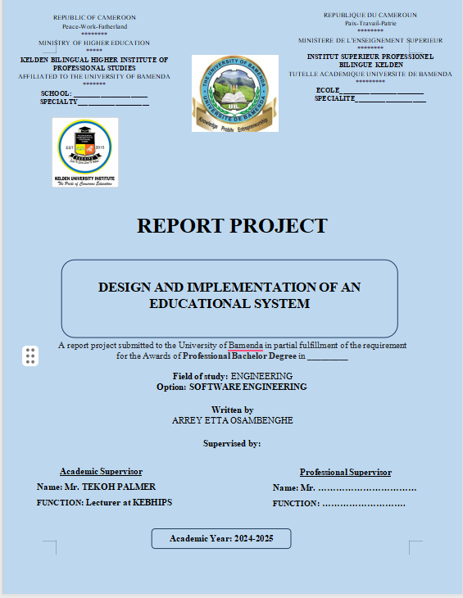

**DECLARATION**

I hereby declare that the project report entitled "DESIGN AND IMPLEMENTATION OF AN EDUCATIONAL MANAGEMENT SYTEM " to Kelden Bilingual Higher Institute of Professional Studies for the requirement of the BSc degree in Software Engineering. It is a record carried out under the supervision of Mr. TEKOH PALMER. I further declare that the work declared in this project has not been submitted either in part or in full, for the award of any degree or diploma in this institute or any other institute or university.

**CERTIFICATION**

This is to certify that the project titled “DESIGN AND IMPLEMENTATION OF ONLINE EXAMINATION MANAGEMENT SYSTEM” with the case study of KELDEN Higher Institute of Professional Studies is a record of independent research work done by **ARREY ETTA OSAMBANGHE** , under the supervision of **Mr. TEKOH PLAMER**  and submitted to Kelden Higher Institute Of Professional Studies, for the reward of a Bachelor Degree In Computer Software Engineering.

**Approved By**

**Academic Supervisor:** Mr. TEKOH PALMER  
**Date:........................................**  
**Signature: ....................................**

**President of Jury**  
Date: ..................................................  
Signature: .............................................

**Member of Jury 1**  
Date: ..................................................  
Signature: .............................................

**Member of Jury 2**  
Date: ..................................................  
Signature: .............................................

**Student:** ARREY ETTA Osambenghe   
Date: ..................................................  
Signature: .............................................

**DEDICATION**

**I dedicate this piece of work to the ARREY ETTA’S family.**

**ACKNOWLEDGEMENT**

All my gratitude goes to my academic supervisor, Mr. TEKOH PALMER, for the support, guidance, time, and energy in writing this project. Special thanks to my lecturers who inspired me so much.

I am grateful to KEBHIPS, MR LEILA LINUS the director of this prestigious institution

and his entire staffs for providing me with the opportunity to acquire knowledge and skills in

a prestigious institution. Their commitment to excellence has enriched my learning

experience significantly.

And to crown it all up, all my gratitude to my parents, Mr./Mrs WILSON MBOK ARREY ETTA, my uncle Mr.ARREY ARREY DIVINE and my brothers for their financial and moral support

Special thanks to my friends Chofor Jamaica and Ngoumou Pascaline

Special recognition is also due to my classmates, whose camaraderie, teamwork, and encouragement have made the learning process smoother and more enjoyable

**ABSTRACT**

The integration of Artificial Intelligence (AI) into educational management systems has emerged as a transformative approach to enhancing the efficiency of school administration and improving teaching and learning outcomes. This study explores the design and implementation of an AI-integrated Educational Management System (EMS) tailored for secondary schools, focusing on automating administrative tasks, personalizing learning experiences, and supporting data-driven decision-making.

Using object-oriented modeling techniques such as UML and system development methodologies like the Unified Process (UP), the study designed a modular system architecture that incorporates AI functionalities including automated grading, adaptive learning, predictive analytics, and intelligent chatbots. Empirical data collected through interviews, observations, and questionnaires provided insights into user needs, challenges, and readiness for AI adoption in schools.

Findings indicate that AI can significantly improve administrative efficiency by automating tasks such as timetabling, attendance tracking, and report generation. Additionally, AI-powered tutoring systems and adaptive learning platforms enhance student engagement and performance. However, the study also identified several barriers to successful implementation, including inadequate digital infrastructure, lack of teacher training, concerns over data privacy, and resistance to technological change.

To ensure effective and sustainable integration, this research recommends strengthening digital infrastructure, providing professional development for educators, establishing ethical guidelines for AI use in education, and adopting a phased implementation strategy supported by stakeholder collaboration.

In conclusion, while the integration of AI into school EMS presents significant opportunities, its success hinges on a balanced approach that combines technological innovation with pedagogical relevance and institutional preparedness.

**Keywords:**Artificial intelligence, Educational Management System, Automating

### ****Résumé****

L’intégration de l’Intelligence Artificielle (IA) dans les systèmes de gestion de l’éducation s’impose comme une approche transformatrice visant à améliorer l’efficacité de l’administration scolaire et à rehausser les résultats d’apprentissage. Cette étude explore la conception et la mise en œuvre d’un Système de Gestion Éducatif (SGE) intégrant l’IA, adapté aux établissements du secondaire, avec un accent mis sur l’automatisation des tâches administratives, la personnalisation des expériences d’apprentissage et le soutien à la prise de décisions basées sur les données.

En utilisant des techniques de modélisation orientées objet telles que UML et des méthodologies de développement logiciel comme le Processus Unifié (UP), l’étude a permis de concevoir une architecture modulaire qui intègre des fonctionnalités d’IA telles que la correction automatisée, l’apprentissage adaptatif, l’analyse prédictive et les chatbots intelligents. Des données empiriques recueillies par le biais d’entretiens, d’observations et de questionnaires ont fourni des éclairages précieux sur les besoins des utilisateurs, les défis rencontrés ainsi que la préparation des acteurs scolaires à adopter l’IA.

Les résultats indiquent que l’IA peut considérablement améliorer l’efficacité administrative en automatisant des tâches telles que l’élaboration des emplois du temps, le suivi de la présence et la génération de rapports. De plus, les systèmes tutoriels et les plateformes d’apprentissage alimentés par l’IA renforcent l’engagement et les performances des élèves. Toutefois, l’étude a également identifié plusieurs obstacles à une mise en œuvre réussie, notamment des infrastructures numériques insuffisantes, un manque de formation des enseignants, des préoccupations liées à la protection des données et une résistance au changement technologique.

Afin d’assurer une intégration efficace et durable, cette recherche recommande de renforcer l’infrastructure numérique, de dispenser une formation professionnelle aux éducateurs, d’établir des directives éthiques pour l’utilisation de l’IA dans l’éducation, et d’adopter une stratégie de déploiement progressive appuyée par une collaboration entre les parties prenantes.

En conclusion, bien que l’intégration de l’IA dans le SGE offre des opportunités significatives, son succès repose sur une approche équilibrée combinant innovation technologique, pertinence pédagogique et préparation institutionnelle.

**Mots-clés :** Intelligence artificielle, Système de gestion éducatif, Automatisation

**LIST OF FIGURES**

Figure 1 : Use Case diagram of The Educational Management System…………………………….32

Figure 2 : Class diagram of The Educational Management System………………………………...33

Figure 3 : Sequence Diagram of The Login System…………………………………………….…..34

Figure 4 : Sequence Diagram of Assignment submission and grading process…………………….35

Figure 5 : Sequence Diagram of AI Risk Detection system…………………………………………35

Figure 6 : Sequence Diagram of The AI chatbot system…………………………………………….36

Figure 7 : Activity Diagram of The AI chatbot System……………………………………………..37

**CHAPTER 1**

**INTRODUCTION**

* 1. **Background of the study**

The rapid evolution of educational technology has transformed how learning is delivered, managed, and experienced. In an era where digital tools are integral to education, schools increasingly rely on integrated platforms to streamline administrative tasks, enhance communication, and improve student outcomes. This study focuses on the development of a school portal designed to address the dynamic needs of students, teachers, and administrators through a unified system. The portal will incorporate features such as profile management, course access, real-time communication, grade tracking, assignment submission, AI-driven analytics, and role-based permissions. By contextualizing this innovation within historical, conceptual, theoretical, and contextual frameworks, this background establishes the rationale for its design and implementation

* + 1. Historical background

The integration of technology in school systems has evolved significantly over the past decades, facing various challenges and opportunities. Early efforts focused on programming and computer literacy, while more recent approaches emphasize curriculum-based integration and future-oriented skills (Dias & Atkinson, 2001). Despite high expectations, the overall impact of technology on education has been limited, largely due to social-situational influences within the educational environment (Gormly, 2018). Successful integration requires addressing barriers at individual, systemic, and student levels (Morgan et al., 2015). A comprehensive approach involves considering both macro-processes over time and micro-processes in specific integration cases (Liu & Velasquez-Bryant, 2003). Effective implementation depends on factors such as relative advantage, compatibility, and observability of the technology (Morgan et al., 2015). To achieve measurable learning benefits, ongoing integration efforts are necessary, focusing on communication, collaboration, and creative problem-solving while preparing students for their future (Dias & Atkinson, 2001).

* + 1. Conceptual background

The integration of technology in education has evolved significantly over the past decades, moving from basic programming to more comprehensive approaches (Dias & Atkinson, 2001). Effective integration requires a holistic strategy supporting faculty, students, and curriculum (Grandgenett et al., 1997). Liu and Velasquez-Bryant (2003) propose a three-dimensional framework encompassing Information, Technology, and Instructional Design, along with two integration models examining macro and micro processes. However, challenges persist, including missing links, misguided directions, and areas of weakness in integration efforts (Liu & Velasquez-Bryant, 2003). Lloyd (2005) emphasizes the need for clearer definitions and understanding of ICT integration to improve measurement and adoption. Best practices in technology integration focus on curriculum-based, future-oriented approaches that promote communication, collaboration, and creative problem-solving (Dias & Atkinson, 2001). As technology becomes more prevalent in classrooms, the focus shifts from adoption to effective implementation in instruction (Dias & Atkinson, 2001).

* + 1. Theoretical background

This review examines theories explaining technology integration in education. Several models are discussed, including the Technology Acceptance Model (TAM), Theory of Planned Behavior (TPB), and Technological Pedagogical Content Knowledge (TPACK) framework (Luhamya et al., 2017; Mohebi, 2021). These theories aim to understand factors influencing technology adoption in teaching and learning. The integration of technology is viewed as a means to enhance student performance and school flexibility (Franklin & Bolick, 2007). However, gaps exist between the vision for technology and its practical implementation in schools. Research indicates that different learning theories coexist in educational settings, with constructivist approaches more likely to utilize Internet-based resources, while behaviorist methods tend to employ instructional software (Altuna & Lareki, 2015). The review highlights the importance of preparing teachers to effectively integrate technology in their teaching practices and calls for further research on the impact of technology integration on student learning capabilities (Mohebi, 2021; Franklin & Bolick, 2007).

* + 1. Contextual background

The integration of technology in school systems is influenced by various contextual factors. In Cyprus, the centralized and bureaucratic educational system poses challenges to ICT implementation (Hadjithoma & Eteokleous, 2007). Belgium's study reveals that both structural (infrastructure, planning, support) and cultural (leadership, goal-orientedness, innovativeness) school characteristics impact ICT integration (Tondeur et al., 2009). In Brazil, despite seemingly homogeneous conditions, schools exhibit unique scenarios in technology integration, emphasizing that material conditions do not determine pedagogical outcomes (Amiel et al., 2016). Lesotho faces practical challenges in integrating technology in secondary geography education, including limited funding, inadequate professional development, and unclear policies (Selialia & Kurata, 2023). These studies highlight the importance of considering systemic conditions, institutional contexts, and cultural factors in understanding and addressing the complexities of technology integration in diverse educational settings.

### ****1.2 STATEMENT OF THE PROBLEM****

The rapid digitization of education has exposed critical inefficiencies in current systems, where fragmented tools and manual processes hinder effective management. Students often juggle multiple platforms to submit assignments, track grades, and communicate with peers, leading to disorganization and disengagement. Teachers are overwhelmed by administrative tasks, such as manual grading and managing scattered course materials, which limits their ability to focus on instruction. Administrators struggle with decentralized systems for user management, course oversight, and data analysis, resulting in delayed decision-making. While existing learning management systems (LMS) like Google Classroom and Canvas offer partial solutions, they lack AI-driven analytics, real-time collaboration tools, and role-specific customization. These gaps perpetuate inefficiencies, reduce transparency, and impede data-driven interventions. For instance, a 2023 study revealed that 65% of educators spend over 10 hours weekly on administrative tasks, while 40% of students report dissatisfaction with feedback delays. This study addresses these challenges by proposing an AI-integrated school portal that unifies communication, grading, course management, and analytics into a single platform, bridging the gap between technological potential and educational practice.

### ****1.3 OBJECTIVES OF THE STUDY****

#### ****1.3.1 Main Objective****

To design and implement an AI-powered school portal that streamlines educational management by integrating student profile management, course access, real-time communication, automated grading, and predictive analytics into a unified platform for students, teachers, and administrators

.

#### ****1.3.2 Specific Objectives****

1. **Design a user-centric interface** tailored to the distinct needs of students, teachers, and administrators, ensuring intuitive navigation and accessibility.
2. **Develop core functionalities** , including assignment submission, grade tracking, real-time notifications, and AI-driven performance dashboards.
3. **Integrate machine learning algorithms** to automate grading for objective assessments and predict student performance trends.
4. **Evaluate the portal’s usability and adoption rates** through pilot testing with stakeholders across urban and peri-urban schools.

### ****1.4 RESEARCH QUESTIONS m****

#### ****1.4.1 General Research Question****

The overarching question guiding this study is: **How can an AI-integrated school portal enhance educational management by streamlining communication, course management, grading, and data-driven decision-making for students, teachers, and administrators?** This question encapsulates the study’s aim to explore how a unified platform can address systemic inefficiencies in educational workflows and improve stakeholder experiences.

#### ****1.4.2 Specific Research Questions****

To address the general research question, the study will investigate the following inquiries:

Firstly, the research will examine how the portal’s interface can be optimized to ensure usability, accessibility, and role-specific customization for students, teachers, and administrators. This involves understanding the unique needs of each user group and designing a platform that adapts to their workflows.

Secondly, the study will identify which core features—such as real-time notifications, assignment submission tools, and grade tracking—are most critical for improving workflow efficiency and stakeholder satisfaction. This includes evaluating how these features address existing pain points like delayed feedback and fragmented communication.

Thirdly, the research will explore how AI-driven tools, including automated grading and predictive analytics, can enhance administrative efficiency, personalize learning experiences, and support the early identification of at-risk students. This involves analyzing the accuracy of AI predictions and their impact on intervention strategies.

Fourthly, the study will assess stakeholders’ perceptions of the portal’s usability compared to existing systems and investigate the factors that influence its adoption. This includes examining barriers such as resistance to change or technical literacy gaps.

Fifthly, the research will measure the portal’s impact on student engagement, academic performance, and administrative efficiency within a single academic term. Quantitative metrics, such as grade improvements and task completion times, will be complemented by qualitative feedback on user experiences.

### ****1.5 RESEARCH HYPOTHESES****

#### ****1.5.1 Specific Hypotheses****

This study formulates the following hypotheses to guide empirical investigation, each derived from the research questions and objectives:

The first hypothesis posits that **a user-friendly interface with role-specific customization will significantly improve stakeholder satisfaction and adoption rates compared to existing fragmented tools** . Conversely, the null hypothesis assumes no significant difference in satisfaction or adoption rates between the new portal and legacy systems.

Secondly, it is hypothesized that **real-time notifications and centralized assignment submission features will reduce delays in feedback and improve student engagement** . The null hypothesis for this claim asserts that real-time features will not significantly impact feedback turnaround times or engagement levels.

Thirdly, the study hypothesizes that **AI-driven predictive analytics will identify at-risk students with ≥80% accuracy, enabling timely interventions** . The null hypothesis counters that AI-driven analytics will not significantly enhance the accuracy of identifying at-risk students compared to traditional methods.

Fourthly, it is proposed that **stakeholders (students, teachers, admins) will report higher usability scores for the portal compared to legacy systems** . The null hypothesis rejects this, suggesting no significant difference in usability perceptions between the two systems.

### ****1.6 SIGNIFICANCE OF THE STUDY****

This study holds substantial value for educational institutions, stakeholders, and the broader academic community by addressing critical inefficiencies in current educational management systems. By designing and evaluating an AI-integrated school portal, the research aims to bridge gaps in communication, administration, and data-driven decision-making, offering transformative benefits across multiple dimensions.

**1.6.1 Practical Significance**

The portal’s development and implementation carry immediate practical implications for students, educators, administrators, and institutions. For students, the platform’s personalized features—such as real-time grade tracking, AI-driven progress reports, and centralized course access—empower learners to take ownership of their education. By reducing reliance on disjointed tools, the portal minimizes confusion and saves time, while its mobile-friendly design ensures equitable access for students in remote or underserved areas. For teachers, automated grading and predictive analytics alleviate administrative burdens, allowing them to focus on instruction and student support. The platform’s communication tools further streamline interactions with students and administrators, fostering a collaborative educational environment. Administrators benefit from centralized control over user permissions, course management, and institutional analytics, enabling data-driven decisions that optimize resource allocation and operational efficiency. Schools adopting the portal gain a competitive edge by embracing innovative technology, enhancing their reputation, and preparing for future educational trends such as hybrid learning. Additionally, the portal’s modular architecture ensures scalability, making it adaptable to institutions with varying resource capacities, from well-funded urban schools to under-resourced rural campuses.

**1.6.2 Academic/Theoretical Significance**

Beyond its practical applications, this study contributes to academic discourse and theoretical frameworks in educational technology. By integrating AI into a unified platform, the research provides empirical evidence on the efficacy of machine learning in education, addressing gaps in existing literature related to predictive analytics, automated grading, and user trust in AI systems. The portal’s design, grounded in user-centered principles, offers a model for aligning technological innovation with pedagogical needs, demonstrating how intuitive interfaces can enhance adoption rates and satisfaction. Furthermore, the study explores ethical considerations in AI deployment, emphasizing transparency and data privacy safeguards. These insights advance ongoing debates about responsible AI use in education and inform the development of ethical guidelines for future technologies. The research also establishes a replicable framework for evaluating educational tools, offering benchmarks for assessing usability, scalability, and impact. Policymakers can leverage these findings to advocate for infrastructure investments—such as improved internet connectivity—and regulatory frameworks that support equitable access to digital education tools.

**1.7 JUSTIFICATIONS OF THE STUDY**

This study is justified by the urgent need to address inefficiencies in educational management systems, which have been exacerbated by the growing reliance on fragmented digital tools. Despite the availability of learning management systems (LMS) like Google Classroom and Canvas, schools continue to face challenges such as delayed feedback, poor data integration, and a lack of AI-driven insights to support decision-making. Existing platforms often require manual workarounds, increasing administrative burdens and limiting scalability. Furthermore, the rapid shift toward hybrid and remote learning models has highlighted the need for a unified portal that combines communication, grading, analytics, and accessibility in one system. This study responds to these gaps by proposing an AI-integrated portal tailored to the needs of students, teachers, and administrators. It also aligns with global priorities, such as UNESCO’s Sustainable Development Goal 4 (Quality Education), by promoting equitable access to technology and data-driven educational practices. The research is further justified by its potential to generate actionable insights for policymakers, educators, and developers, offering a scalable framework for future innovations in educational technology.

**1.8 DELIMITATION OF THE STUDY**

To ensure focus and feasibility, the study is delimited by thematic, geographical, and temporal boundaries.

**1.8.1 Thematic Scope**

The research focuses specifically on the design, development, and evaluation of an AI-integrated school portal for educational management. It prioritizes core functionalities such as profile management, course access, real-time communication, grading, and analytics. While the portal incorporates AI tools for predictive analytics and automated grading, it does not explore advanced AI applications like natural language processing (NLP) for essay grading or virtual reality (VR) classrooms. The study emphasizes usability, adoption rates, and administrative efficiency rather than broader socio-cultural impacts of technology in education.

**1.8.2 Geographical Scope**

The study is delimited to urban and peri-urban schools in Yaounde Cameroon , where access to basic digital infrastructure (e.g., internet connectivity, devices) is feasible. Rural schools with limited technological resources are excluded due to constraints in implementation and scalability during the pilot phase. However, the portal’s modular design will include considerations for low-bandwidth environments to inform future adaptations.

**1.8.3 Time Scope**

The research will be conducted over 2 months , divided into four phases:

Weeks 1–2 : Literature review, user surveys, and prototype design.

Weeks 3–6 : Portal development and AI integration.

Week 7 : Pilot testing in selected schools and data collection.

Week 8 : Analysis, reporting, and framework proposal.

CHAPTER 2

LITERATURE REVIEW

**2.1 Conceptual Review**

The integration of Artificial Intelligence (AI) into school educational management systems represents a transformative shift in how educational institutions plan, organize, monitor, and deliver learning experiences. This conceptual review outlines the key constructs involved in this integration.

**- Artificial Intelligence (AI)**

AI refers to the simulation of human intelligence by machines that are programmed to perform tasks such as reasoning, problem-solving, perception, and decision-making (Russell & Norvig, 2020). In education, AI encompasses technologies like machine learning, natural language processing, data mining, and intelligent tutoring systems.

**- Educational Management System (EMS)**

An EMS is a digital platform used by schools to manage administrative and academic functions. These include student information systems, resource planning, performance tracking, communication tools, curriculum delivery, and assessment mechanisms (UNESCO, 2021).

**- Integration of AI in EMS**

This concept involves embedding AI-driven tools within existing EMS frameworks to enhance efficiency, personalization, and decision-making. Examples include automated grading systems, adaptive learning platforms, predictive analytics for student performance, chatbots for administrative queries, and data-driven policy formulation.

**Key Concepts in Integration**

**- Automation :** Reducing manual work in administrative and instructional tasks.

**- Personalization :** Tailoring learning experiences based on individual learner needs.

**- Data Analytics :** Using large datasets to inform decisions about student progress and institutional effectiveness.

- strategic planning.

- Despite the growing interest, there remain conceptual ambiguities regarding what constitutes "true AI integration," particularly distinguishing between AI-assisted tools and fully autonomous AI systems in educational settings.

**2.2 Theoretical Review**

This section explores theoretical foundations that guide the understanding and application of AI in educational management systems.

**1. Technology Acceptance Model (TAM)**

Davis (1989) proposed TAM to explain how users accept and use technology. It posits that perceived usefulness and ease of use significantly influence user behavior. In the context of AI in EMS, TAM helps understand teacher and administrator adoption of AI tools.

Example: A study by Alalwan et al. (2017) applied TAM to assess teachers’ willingness to adopt AI-based classroom tools, finding that perceived usefulness was a stronger predictor than ease of use.

**2. Diffusion of Innovations (DOI) Theory**

Rogers (1962) introduced DOI to explain how new technologies spread through social systems. According to this theory, the rate of adoption depends on attributes such as relative advantage, compatibility, complexity, trialability, and observability.

Application: Schools with supportive leadership and adequate infrastructure are more likely to adopt AI-based EMS due to perceived advantages over traditional systems.

**3. Constructivist Learning Theory**

Piaget (1954) and Vygotsky (1978) emphasized learning as an active process where learners construct knowledge through interaction. AI systems that support adaptive and interactive learning environments align well with constructivist principles.

Example: AI tutors that adjust content based on student responses reflect the scaffolding principle from Vygotsky’s Zone of Proximal Development.

**4. Systems Theory**

Bertalanffy (1968) proposed that organizations function as interrelated systems. Applying systems theory to AI integration highlights the need for alignment between technological components (e.g., software), human elements (teachers, students), and organizational structures (school policies, governance).

These theories collectively provide a robust framework for understanding not only the technical feasibility but also the socio-organizational dynamics of integrating AI in educational management systems.

**2.3 Empirical Review (Review by Objectives)**

This section organizes empirical studies according to the research objectives related to the integration of AI in school educational management systems.

**Objective 1:** To examine the impact of AI integration on administrative efficiency in schools

Several studies have demonstrated that AI improves administrative processes in schools:

**Automated Scheduling :** AI algorithms can optimize timetables, reducing conflicts and saving time (Zhang et al., 2020).

**Student Information Management :** AI-enhanced systems streamline enrollment, attendance tracking, and report generation (Khan et al., 2021).

**Predictive Analytics :** Schools using AI for early warning systems have reported improved dropout prediction and intervention strategies (Romero & Ventura, 2020).

However, challenges such as high initial costs and resistance from staff unfamiliar with AI were noted (Adu-Gyamfi et al., 2022).

**Objective 2:** To assess the effect of AI on teaching and learning processes within school EMS

AI has been shown to enhance both instruction and learning outcomes:

**Adaptive Learning Platforms :** Tools like Knewton and DreamBox personalize learning paths for students (Pane et al., 2014).

**Intelligent Tutoring Systems (ITS) :** These systems provide immediate feedback and guidance, improving student engagement and comprehension (Nye et al., 2016).

**AI-Based Assessment :** Automated grading systems reduce teacher workload and improve consistency in evaluation (Sherman, 2019).

Nonetheless, concerns about reduced human interaction and ethical implications (e.g., bias in algorithmic decisions) remain unresolved (Williamson, 2020).

**Objective 3:** To identify challenges and barriers to AI integration in school EMS

Empirical findings reveal several common barriers:

**Technical Challenges :** Lack of reliable internet, outdated hardware, and insufficient IT support (Mutshewa et al., 2021).

**Teacher Readiness :** Many educators lack training and confidence in using AI tools (Chen et al., 2020).

**Policy and Governance Gaps :** Absence of national guidelines or standards for AI in education limits scalability (UNESCO, 2022).

**Privacy and Data Security Concerns :** Parents and educators express anxiety about student data being collected and analyzed by AI systems (Andrä et al., 2021).

2.3 INTERNSHIP REPORT

In this section of my work, I present my internship experience carried out at Alpha Tech , a technology firm specializing in software development and IT solutions, from April 5 to May 15, 2024 . During this period, I collaborated with skilled professionals and gained hands-on experience in software engineering and project management. Below is a summary of the key activities undertaken during the internship.

2.4 PRESENTATION OF THE ENTERPRISE (INTERNSHIP)

Alpha Tech is a leading technology firm headquartered in Yaounde Cameroon , offering end-to-end software development, cloud computing, and cybersecurity solutions. The company caters to clients across industries such as finance, healthcare, and education, providing innovative tools to streamline operations and enhance digital transformation. With a team of seasoned developers, data scientists, and IT consultants, Alpha Tech has established itself as a trusted partner for businesses seeking scalable and secure technological solutions.

2.4.1 PRESENTATION OF THE INTERNSHIP

My internship at Alpha Tech commenced on Wednesday, April 5, 2025 , and lasted for six weeks under the supervision of Mr. MR. KENNE FOMA , the lead software engineer, and MR NTENGHO CLARKSON , the project manager. This internship was a transformative opportunity to apply academic knowledge to real-world challenges while gaining exposure to agile development practices and collaborative workflows. The experience also allowed me to reflect on my technical competencies, communication skills, and adaptability in a fast-paced professional environment.

2.4.2 ACTIVITIES CARRIED OUT

Below is a breakdown of activities during the internship:

Week 1 : Orientation to company workflows, tools (Git, Jira), and project requirements.

Week 2 : Training on Python programming and Django framework for backend development.

Week 3 : Participation in designing a RESTful API for a client’s inventory management system.

Week 4 : Collaborative coding sessions to debug and optimize existing codebases.

Week 5 : Introduction to cloud deployment using AWS (Amazon Web Services).

Week 6 : Final testing of the developed application, documentation, and presentation to stakeholders.

2.4.3 INTERNSHIP EXPERIENCE

This internship provided practical insights into the software development lifecycle, from requirement analysis to deployment. Under my supervisor’s guidance, I mastered tools like Docker for containerization, Postman for API testing, and AWS for cloud hosting. Key takeaways included:

Improved coding efficiency through version control (Git) and agile practices.

Enhanced problem-solving skills by troubleshooting backend logic errors.

Exposure to cross-functional teamwork during sprint planning and review meetings.

Developed a deeper understanding of client-server architecture and data security protocols.

2.4.4 STRENGTHS AND WEAKNESSES

STRENGTHS

Alpha Tech boasts a highly skilled workforce with expertise in emerging technologies like AI, machine learning, and cloud computing. The company’s agile methodology and collaborative culture foster innovation and rapid prototyping. Additionally, its robust infrastructure—such as high-speed internet, cloud resources, and modern workstations—ensured seamless project execution.

WEAKNESSES

A notable weakness was the lack of a structured onboarding process for interns, leading to delays in accessing project documentation and tools. Furthermore, limited mentorship opportunities during peak workloads occasionally hindered knowledge transfer.

2.4.5 PROBLEMS ENCOUNTERED

Key challenges during the internship included:

Access Delays : Difficulty in obtaining permissions for critical software tools (e.g., AWS consoles).

Communication Gaps : Ambiguous task assignments due to overlapping project responsibilities.

Technical Hurdles : Limited debugging support during complex backend integrations.

**2.4.6 RECOMMENDATIONS**

To address the above challenges, the following solutions are proposed:

Streamline Onboarding : Develop a centralized repository for project documentation and tool access guides for interns.

Enhance Mentorship : Assign dedicated mentors to interns to provide regular feedback and clarify task priorities.

Improve Collaboration : Adopt tools like Slack or Microsoft Teams for real-time communication and task tracking.

Structured Training : Organize weekly workshops on advanced topics (e.g., CI/CD pipelines, DevOps practices) to bridge knowledge gaps.

**CONCLUSION**

The internship at Alpha Tech was instrumental in bridging the gap between theoretical learning and practical application. It reinforced my passion for software development while highlighting areas for personal and organizational growth. I am grateful for the opportunity to contribute to meaningful projects and collaborate with industry experts.

**CHAPTER 3**

**METHODOLOGY AND MATERIALS USED**

**3.1 Introduction**

This chapter outlines the research methodology and materials employed in the study titled “Integrating AI in School Educational Management Systems.” The purpose of this research is to explore how Artificial Intelligence (AI) is being integrated into educational management systems in schools, its impact on administrative and instructional processes, and the challenges associated with such integration.

The methodology section provides a detailed description of the research design, population and sampling techniques, data collection methods, data analysis procedures, and ethical considerations. This ensures that the study is conducted systematically, yielding reliable and valid results. The research adopts a mixed-methods approach, combining both quantitative and qualitative techniques to capture a comprehensive understanding of AI integration from multiple perspectives—including school administrators, teachers, and IT personnel.

Additionally, this chapter discusses the instruments used in gathering data, such as questionnaires, interviews, and document analysis, along with the procedures followed during data collection. It also highlights the limitations of the study and justifies the chosen methods in relation to the research objectives and questions.

By clearly presenting the methodology and materials used, this chapter enhances the transparency, credibility, and replicability of the research findings.

**3.2 Description of the Architecture of the System or Application**

1. Overview of the System Architecture

The system follows a multi-tier architecture model, comprising the following layers:

a) Presentation Layer (User Interface)

This is the front-end component with which users interact. It includes web and mobile interfaces accessible by various stakeholders such as:

Administrators

Teachers

Students

The interface is designed to be responsive, intuitive, and role-based, ensuring that each user group accesses only the relevant features and data.

b) Application Logic Layer (Business Logic)

This middle layer processes data, executes business rules, and coordinates communication between the presentation and database layers. It hosts the key AI functionalities such as:

- Adaptive learning engines

- Predictive analytics modules

- Chatbots

These components are built using machine learning models trained on historical and real-time data collected from within the system.

c) Data Layer (Database & Storage)

This back-end layer stores all system data including student records, performance metrics, curriculum content, and administrative logs. The data is stored in a centralized relational database Sanity.io , with provisions for secure backups

Additionally, a data warehouse is used to aggregate large volumes of structured and unstructured data for AI processing and analytics.

2. Functional Modules of the AI-Integrated EMS

The system comprises several interconnected modules, each enhanced with AI capabilities:

a) Student Information Management

Uses predictive analytics to identify at-risk students and recommend interventions.

b) Academic Performance Monitoring

Delivers personalized learning recommendations based on student performance data.

c) Adaptive Learning Platform

Utilizes AI algorithms to tailor content delivery to individual learning styles and paces.

Supports interactive tutoring through intelligent tutoring systems (ITS).

d) Administrative Decision Support

Provides dashboards with real-time analytics for resource allocation, budgeting, and policy planning.

Uses natural language processing (NLP) for generating reports and answering administrative queries via chatbots.

e) Communication and Collaboration Tools

Includes AI-powered chatbots for answering common inquiries from students.

1. Security and Privacy Considerations

Given the sensitive nature of student and institutional data, the architecture incorporates:

- End-to-end encryption for data in transit and at rest.

- Role-based access control (RBAC).

- Compliance with data protection regulations such as GDPR and FERPA.

- Anonymization techniques for AI training data to prevent bias and protect privacy.

**3.3 Data Collection Method and User’s Needs**

3.3.1 Observation

Observation was used as a primary method to gather firsthand information about the functioning of existing school educational management systems. Researchers conducted both structured and participant observations in selected schools.

Purpose of Observation

- To understand how administrative and academic tasks are currently being managed.

- To identify bottlenecks and inefficiencies in the system.

- To observe how staff interact with digital tools and where automation could be beneficial.

The observational findings provided critical insights into the operational dynamics of the school environment and served as a foundation for identifying areas suitable for AI intervention.

3.3.2 Interviews

Semi-structured interviews were conducted with key stakeholders involved in the educational process. These included school administrators , teachers , IT personnel and Student .

Purpose of Interviews

- To gather in-depth perspectives on the strengths and weaknesses of the current EMS.

- To explore attitudes toward AI and its potential role in education.

- To collect suggestions and concerns from users regarding AI adoption.

Interview Structure

Each interview followed a semi-structured format with open-ended questions that allowed participants to express their views freely. Sample questions included:

- How do you currently use the educational management system?

- What are the major challenges you face in managing academic or administrative tasks?

- How do you perceive the use of AI in education?

- What features would you expect from an AI-enhanced EMS?

Participants

A purposive sampling technique was used to select 18–30 participants across different roles to ensure diverse viewpoints.

**3.3.3 User’s Needs**

Key Stakeholders and Their Needs

- School Administrators

Streamlined operations, predictive analytics for resource allocation, automated reporting, and policy support.

- Teachers

Tools for personalized learning, automated grading, real-time performance tracking, and adaptive teaching aids.

- Students

Personalized learning paths, instant feedback, interactive learning environments, and accessibility.

- IT Personnel

Scalable infrastructure, integration capabilities, security protocols, and maintenance support.

3.4 Functional Requirements

Functional requirements define what the system must do or allow users to accomplish. These are derived from the user needs identified through interviews, observations, and literature review. The functional requirements for the AI-integrated educational management system include:

- The system shall allow administrators to manage student and staff records.

- The system shall support automated timetabling and scheduling.

- The system shall provide real-time academic performance tracking for students.

- The system shall generate automated reports and analytics for teachers and administrators.

- The system shall support adaptive learning paths based on individual student performance.

- The system shall integrate an intelligent tutoring system (ITS) to assist students in self-paced learning.

- The system shall offer a chatbot feature for answering frequently asked questions related to school operations.

- The system shall include predictive analytics for identifying at-risk students and recommending interventions.

3.5 Function Specifications

3.5.1 Role Played by Each Actor in the System

An actor refers to any entity (human or external system) that interacts with the system. Based on the system's purpose and scope, the following actors were identified:

1. Administrator

Role : Manages the overall system settings, users, data, and policies.

Responsibilities :

- Manage staff and student records.

- Assign roles and permissions.

- Monitor system usage and performance.

- Generate reports and make strategic decisions using AI-generated insights.

2. Teacher

Role : Delivers instruction and monitors student performance.

Responsibilities :

- Upload lessons, assignments, and course materials.

- Monitor student engagement and performance.

- Use AI tools for personalized teaching recommendations.

3. Student

Role : Learns and interacts with learning materials and assessment tools.

Responsibilities :

- Access learning resources and modules.

- Complete quizzes, tests, and assignments.

- Receive adaptive learning suggestions and instant feedback.

- Participate in interactive AI-powered tutoring sessions.

4. AI Module

Role : Provides intelligent automation, analysis, and decision support.

Functions :

- Predictive analytics for student performance.

- Adaptive learning path generation.

- Natural language processing for chatbots.

3.5.2 Functionalities of the System

The following functionalities are embedded into the system to meet the defined requirements and serve the roles effectively:

1. User Management

- Registration and authentication of users (administrators, teachers, students, parents).

- Role-based access control to ensure data privacy and system integrity.

2. Timetable and Scheduling

- AI-based algorithm for generating optimized timetables.

- Automatic conflict resolution and resource allocation.

3. Learning Content Delivery

- Integration of digital textbooks, videos, and interactive modules.

- AI-driven recommendations based on learning style and performance history.

4. Adaptive Learning Engine

- Personalized learning paths generated dynamically.

- Difficulty level adjustments based on student progress.

5. Intelligent Tutoring System (ITS)

- Interactive virtual tutor for subject-specific assistance.

- Instant feedback and explanations during practice exercises.

6. Assessment and Grading

- Creation and management of online quizzes and exams.

- AI-based auto-grading of objective and descriptive answers.

- Generation of detailed performance reports.

7. Communication Tools

- Messaging platform for teacher-student and parent-school communication.

- AI-powered chatbot for answering common queries about schedules, results, etc.

8. Reporting and Analytics

- Automated report card generation.

- Customizable dashboards for different user roles.

- Exportable data formats (PDF, Excel, CSV).

**3.6 Technical Specifications**

- Operating System: Windows 10/11 or Linux (Ubuntu/CentOS) for servers; Android/iOS for mobile apps

- Web Server: Apache HTTP Server / Nginx

- Backend Framework: Node.js with Express

- Frontend Framework: React.js for web

- Database Management System: MySQL (relational)

- Server: Dual-core processor, 8GB RAM, 500GB HDD/SSD

- Client Devices: PC/Tablet/Mobile with internet access and modern browser

- Network: Stable internet connection (minimum 4 Mbps upload/download)

**3.7 Non-Technical Specifications**

1. Usability and Accessibility

The system must be user-friendly and accessible to users with varying levels of digital literacy.

2. Training and Support

Users (teachers, administrators, parents) will require training sessions to effectively use the system.

3. Legal and Ethical Considerations

The system must comply with national and international regulations regarding student data privacy

4. Institutional Readiness

Schools must have basic digital infrastructure (internet, devices, electricity).

5. Cultural and Social Acceptability

The system must respect local cultural norms and teaching practices.

**3.8 Research Design**

Stages of the Research Design

Qualitative Phase :

- Conducted observations and semi-structured interviews with school administrators, teachers, IT personnel, and parents.

- Aimed at understanding current EMS usage, perceived challenges, and expectations from AI integration.

Quantitative Phase :

- Designed and administered questionnaires based on insights from the qualitative phase.

- Collected data from a larger sample of stakeholders to quantify attitudes, readiness, and perceived benefits of AI integration.

Integration Phase :

- Combined and compared qualitative and quantitative findings to provide a holistic understanding of AI adoption in EMS.

**3.9 Analysis Methods**

To ensure accurate interpretation of the collected data, appropriate analysis methods were applied to both qualitative and quantitative datasets.

1. Qualitative Data Analysis

a) Thematic Analysis

Thematic analysis was used to identify patterns and themes within interview transcripts and observational notes. The process included:

-Data Coding : Interview responses were transcribed and coded using open coding techniques.

-Theme Development : Similar codes were grouped into broader themes related to AI integration, such as "readiness," "barriers," and "perceived benefits."

-Interpretation : Themes were interpreted to draw conclusions about stakeholder perspectives.

2. Quantitative Data Analysis

a) Descriptive Statistics

Frequency distributions, percentages, means, and standard deviations were computed to summarize demographic information and respondents’ attitudes toward AI integration.

b) Inferential Statistics

- Correlation Analysis : To determine relationships between variables such as age, experience with digital tools, and willingness to adopt AI.

- Regression Analysis : To assess which factors significantly influence the acceptance of AI in EMS (e.g., ease of use, usefulness).

c) Software Tools

- SPSS and Microsoft Excel were used for statistical analysis.

**3.10 Object-Oriented Methods**

Object-oriented methods are widely used in software development to model, design, and implement complex systems such as educational management systems enhanced with Artificial Intelligence (AI). These methods facilitate modular development, reusability, and maintainability of code by organizing software around data (objects) rather than logic and functions.

In the development of the AI-integrated school educational management system, object-oriented methodologies were applied to ensure clarity, flexibility, and scalability of the system architecture. The following object-oriented methods were considered:

**3.10.1 OMT (Object Modeling Technique)**

The Object Modeling Technique (OMT) was one of the earliest and most influential object-oriented methodologies, developed by James Rumbaugh and his colleagues in the late 1980s. It provides a structured approach to modeling systems using three interrelated models:

1. Object Model

Describes the static structure of the system in terms of objects, their attributes, operations, and relationships.

For this study, the object model defined entities such as Student, Teacher, Administrator, Course, Assessment, and AI_Tutor.

2. Dynamic Model

Captures the behavior of the system through state transitions and event sequences.

In the context of the EMS, it was used to model user interactions, such as login, assignment submission, or grade update workflows.

3. Functional Model

Represents the data flow and transformation processes within the system.

It helped define how inputs (e.g., student performance data) are processed into outputs (e.g., AI-generated learning recommendations).

Application in This Study :

OMT was primarily used during the early design phase to understand system components and their interactions before moving to more modern modeling techniques like UML.

3.10.2 UML (Unified Modeling Language)

The Unified Modeling Language (UML) is a standardized visual modeling language used to specify, visualize, construct, and document software systems. It supports both structural and behavioral modeling and is widely accepted in modern software engineering practices.

Key Diagrams Used in the System Development

- Use Case Diagram: Identified functionalities from the perspective of users (actors) such as Administrator, Teacher, Student, Parent, and AI Module.

- Class Diagram: Represented the structure of the system by showing classes, attributes, operations, and relationships between them.

- Sequence Diagram: Illustrated the interaction between different components of the system over time (e.g., how the AI grading module interacts with the assessment module).

- Activity Diagram: Modeled the workflow of system processes such as automated grading or attendance tracking.

- Component Diagram: Showed how different parts of the system (e.g., chatbot, database, analytics dashboard) are interconnected.

Benefits of Using UML :

- Enhanced communication among developers, stakeholders, and designers.

- Facilitated early detection of design flaws.

- Enabled documentation that supports future maintenance and enhancement.

**3.10.3 UP (Unified Process) Method**

The Unified Process (UP) is an iterative and incremental software development methodology that integrates object-oriented principles and UML. It divides the development life cycle into four phases and emphasizes risk-driven development and continuous refinement.

Four Phases of UP Used in This Study

1. **Inception:**

Defined the scope, objectives, and feasibility of the AI-integrated EMS. Stakeholders were identified, and initial requirements were gathered.

2. **Elaboration**:

Developed a detailed architectural blueprint, created use cases, and performed domain modeling. Risks were identified and mitigated at this stage.

3. **Construction:**

Involved actual coding, testing, and integration of system components. AI modules were trained and deployed in this phase.

4. **Transition:**

Final system testing, user feedback collection, bug fixing, and deployment to selected schools for pilot testing.

Key Characteristics of UP Applied

**- Iterative Development :** Allowed for gradual improvements based on user feedback.

**- Use-Case Driven** : All activities were centered around the functional needs of users.

**- Architecture-Centric :** Emphasis was placed on building a robust, scalable, and secure system architecture.

**- Risk-Focused :** Potential risks such as data privacy issues and technical limitations were addressed early in the process.

**3.11 Functional Methods**

Functional methods are systematic approaches used in the analysis and design of information systems to model processes, data flows, and organizational structures. These methods help in understanding how a system operates, what functions it performs, and how data moves within it.

In the development of the AI-integrated educational management system (EMS), functional modeling techniques were applied to ensure that all operational requirements were clearly defined and logically organized. The following functional methods were utilized:

**3.11.1 SADT Method (Structured Analysis and Design Technique)**

The SADT (Structured Analysis and Design Technique) method is a functional modeling technique developed by Douglas T. Ross in the 1970s. It is widely used in systems engineering and software development to represent complex systems as a set of interconnected functions or activities.

**Key Features of SADT**

Uses block diagrams to represent functions.

Emphasizes data flow and control flow between system components.

Supports top-down decomposition , allowing complex systems to be broken into manageable parts.

**SADT Diagram Elements**

- Block: Represents a function or process (e.g., “Generate Report”).

- Arrow: Represents input, output, control, or mechanism data or resources associated with a block.

**Application in This Study**

- Used during the early stages of system analysis to map out the core functionalities of the EMS, such as student registration, attendance tracking, and AI-based performance prediction.

- Helped identify key inputs (e.g., student data), outputs (e.g., reports), controls (e.g., user roles), and mechanisms (e.g., AI algorithms).

- Enabled developers and stakeholders to visualize system behavior before moving on to more detailed design phases.

**Advantages of Using SADT**

- Promotes clarity in defining system boundaries and responsibilities.

- Facilitates communication among technical and non-technical stakeholders.

- Helps in identifying inefficiencies and areas where AI can enhance automation.

**3.11.2 MERISE Method**

The MERISE method is a French-originated methodology for information system design and development, introduced in 1979. It is particularly effective for designing large-scale administrative and transactional systems like educational management systems.

MERISE is based on a three-level abstraction approach , separating the modeling of data and processes across different levels of detail:

Three Abstraction Levels in MERISE

**- Conceptual Level:** Describes what the system does without considering implementation details.

**- Logical Level:** Defines how the system will work independently of technology.

**- Physical Level:** Specifies how the system will be implemented using specific technologies.

Two Types of Models in MERISE

**- Data Model (Modèle Conceptuel de Données – MCD):**

Focuses on entities and relationships.

For this study, entities included Student, Teacher, Course, Assessment, and AI_Tutor.

**- Process Model (Modèle Conceptuel de Traitement – MCT):**

Describes the operations and interactions between actors and processes.

In the EMS context, it was used to model workflows such as "submit assignment," "generate report card," and "predict at-risk students."

**Application in This Study**

- MERISE was used to formalize both data structures and business processes of the AI-integrated EMS.

- The conceptual models provided a clear foundation for database design and system workflow planning.

- Logical and physical models guided the selection of appropriate databases (MySQL/MongoDB) and system architecture (client-server/cloud-based).

**Advantages of Using MERISE**

Provides a rigorous and structured way to model both data and processes.

Allows for modular development and future scalability.

Facilitates alignment between business needs and technical implementation.

**3.12 Choice of Method**

Object-oriented methods such as UML (Unified Modeling Language) , OMT (Object Modeling Technique) , and the Unified Process (UP) were chosen due to their ability to:

- **Model Real-World Entities :** These methods allow developers to represent real-world entities like students, teachers, courses, and AI modules as objects, making the system more intuitive and aligned with actual school operations.

- **Support Modularity and Reusability :** By organizing the system into classes and objects, it becomes easier to maintain, extend, and reuse components across different parts of the system or in future projects.

- **Facilitate Collaboration :** UML diagrams provide a common visual language understood by developers, educators, and stakeholders, improving communication and reducing ambiguity.

- **Enable Iterative Development :** The Unified Process (UP), which is iterative and incremental, allowed for continuous refinement based on feedback from users and evolving requirements during the development cycle.

**3.13 Application of UML Method**

The Unified Modeling Language (UML) was employed as a key modeling tool during the design and development of the AI-integrated school educational management system (EMS). UML provided a standardized way to visualize the system architecture, behavior, and interactions among its components. This object-oriented modeling technique enabled both technical developers and non-technical stakeholders to understand the structure and dynamics of the system before implementation.

**3.13.1 Actors**

In UML terminology, an actor is any entity that interacts with the system. Based on the scope and functionalities of the AI-integrated EMS, the following actors were identified:

- Administrator

Manages system settings, user accounts, and institutional data; oversees analytics and decision-making.

- Teacher

Uploads learning content, monitors student progress, and uses AI tools for adaptive teaching.

- Student

Accesses lessons, submits assignments, receives feedback, and engages with AI tutors.

- AI Module

Performs automated tasks such as generating reports, generating learning recommendations, predictive analytics, and chatbot responses.

These actors interact with various system modules depending on their roles and access rights.

**3.13.2 Diagrams**

**1. Use Case Diagram**

This diagram illustrates the functional requirements of the system by showing how each actor interacts with the system to achieve specific goals.

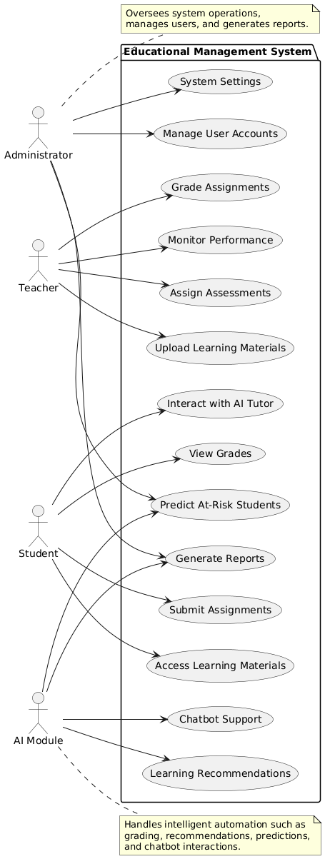

**Figure 1: Use Case Diagram of Educational Management System**

**2. Class Diagram**

The class diagram represents the static structure of the system by defining classes, attributes, methods, and relationships between them.

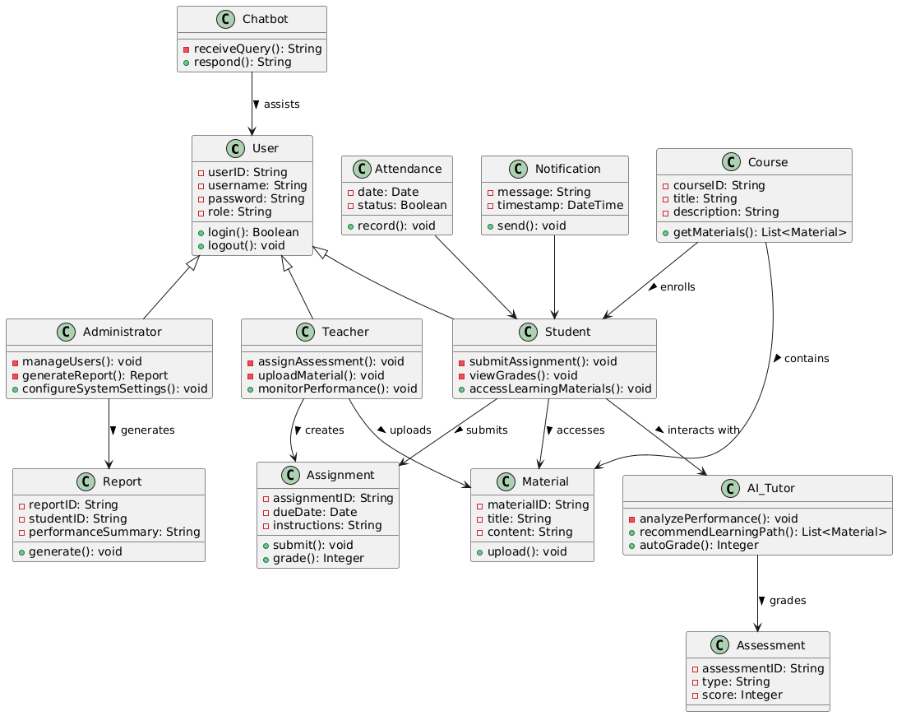

**Figure 2: Class Diagram of Educational Management System**

**3. Sequence Diagram**

This dynamic diagram shows the interaction between objects over time, focusing on the sequence of messages exchanged.

1.

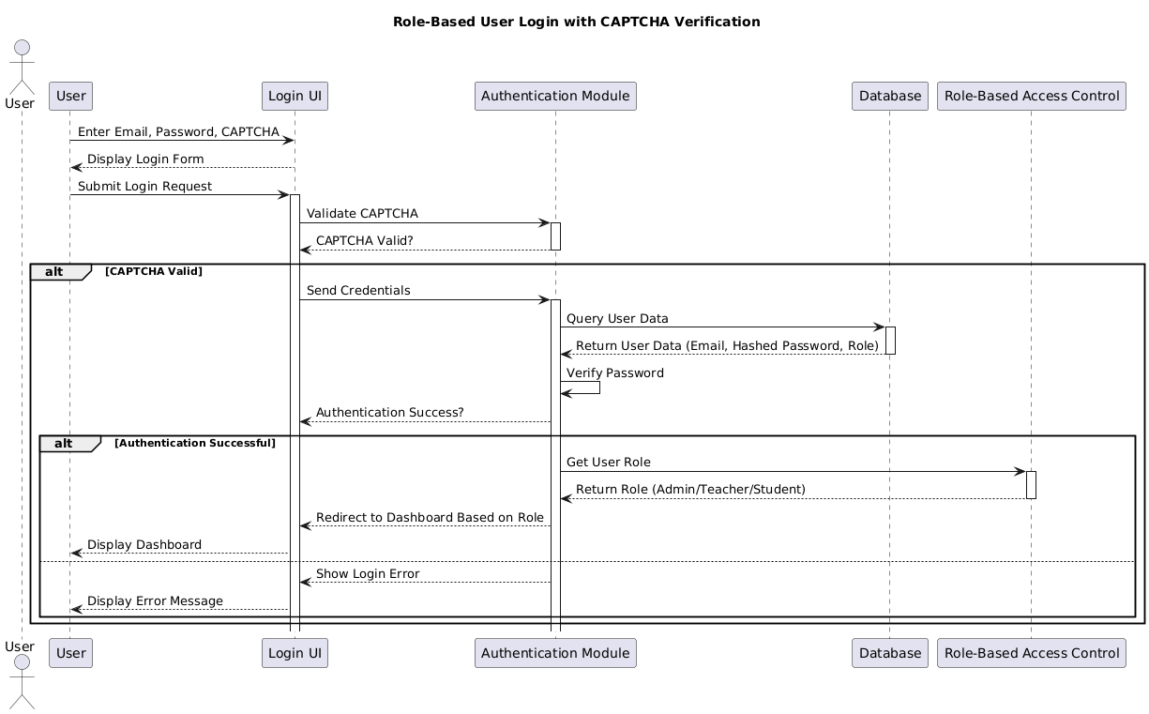

**Figure 3: Sequence Diagram of the Login process**

The diagram above shows the processes involved in the login of a user

2.

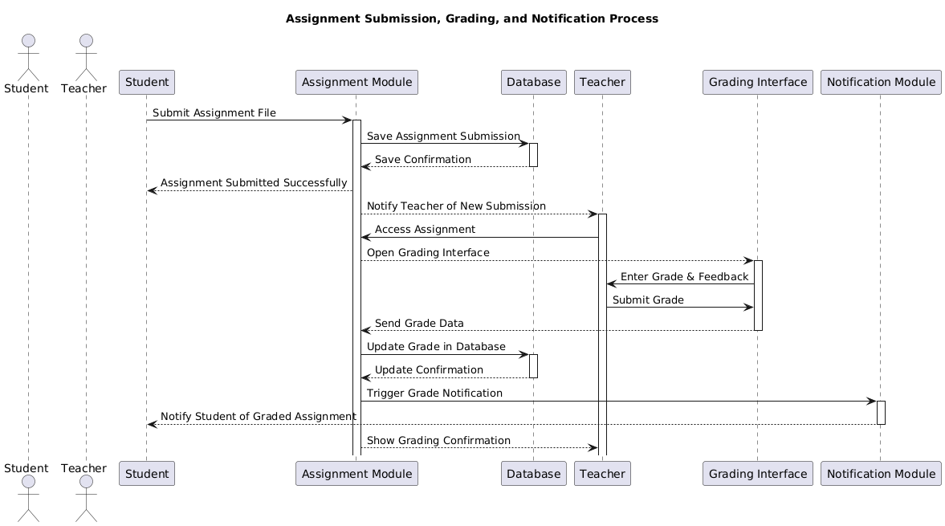

**Figure 4:Sequence Diagram of the Assignment submission and grading process**

The diagram above show the processes involved in the grading, submission and notification process

3.

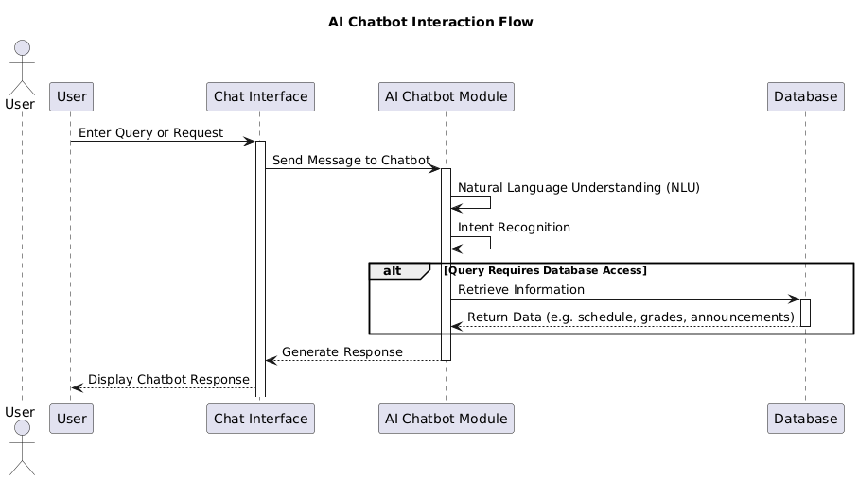

Figure 5: Sequence Diagram of the AI chotbot interaction flow

The diagram above shows the interaction of a user with the AI chatbot

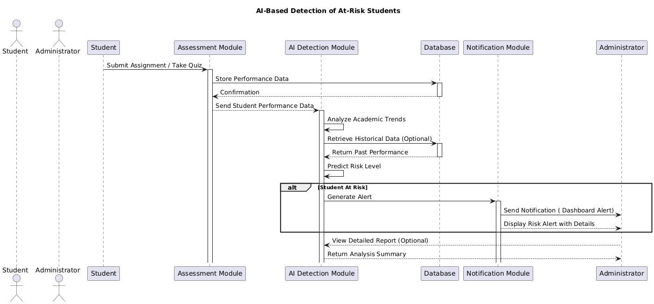

**Figure 6 : Sequence Diagram for Risk Detection for student**

The diagram above show the processes involved for the AI module to detect a student at risk

4. Activity Diagram

Activity diagrams model the workflow of activities and actions performed by users and the system.

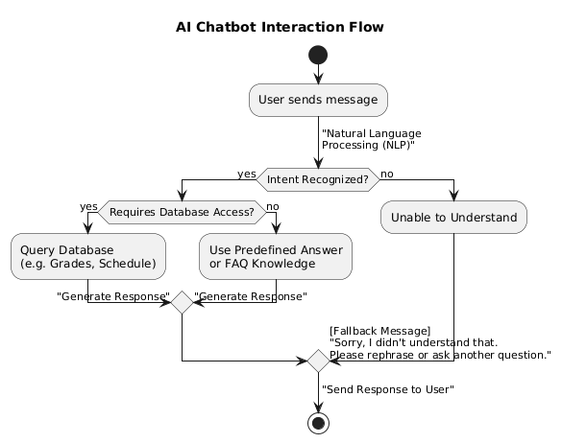

**Figure 7: Activity Diagram for AI Chotbot**

**3.13.3 Components of the System or Application**

Based on the UML modeling, the AI-integrated EMS was composed of several interconnected components designed to perform specific functions. Each component was developed as a separate module to allow for scalability and ease of maintenance.

1. Authentication and Authorization Module

- Handles user login/logout.

- Manages role-based access control.

2. Learning Management Module

- Stores and delivers digital content.

- Tracks student engagement and progress.

3. Assessment and Grading Module

- Allows teachers to create quizzes and assignments.

- Allows teachers to grade submissions and provide feedback.

4. Adaptive Learning Module

- Analyzes student performance data.

- Recommends personalized learning paths and resources.

1. Behavior Monitoring Module

- Tracks daily attendance using facial recognition or manual input.

- Flags irregularities and behavioral patterns.

6. Predictive Analytics Dashboard

- Visualizes student performance trends.

- Identifies at-risk students and suggests interventions.

7. Communication and Notification Module

- Enables messaging between teachers, students, and parents.

- Includes AI-powered chatbot for answering frequently asked questions.

8. Reporting and Administrative Tools

- Generates reports on academic performance, and resource usage.

- Supports data export and policy planning.

9. AI Core Engine

- Hosts machine learning models for:

- Natural language processing (NLP) for chatbots

- Predictive modeling for performance analysis

- Recommendation systems for adaptive learning

Each component was developed using modern web technologies and integrated via RESTful APIs to ensure modularity and interoperability.

**3.14 Software used**   
There are various software which were used in developing this platform.They include  
  
- Visual Studio Code  
IDE that was used to write the code.

- WPS  
Used for writing and editing documents   
  
- PlantUML  
Used to draw the UML diagrams

- Chrome  
Used as a to host the site locally(Localhost)

- PostgreSQL(pgAgmin4)

Used as database

- Prisma studio

Used to simplify database interaction with the program

**3.15 Programming Language**

- HTML

- Css  
- javascript

**3.16 Hardware used**

-A personal computer

**3.18 Modules of the Designed System or Application**

The proposed AI-integrated school educational management system (EMS) has been designed as a modular web-based application , allowing for scalability, maintainability, and role-based access. Each module serves a specific function within the system and is tailored to meet the needs of different stakeholders such as administrators, teachers, students, and parents.

Below are the key functional modules of the system:

1. User Authentication Module

Function : Manages user login/logout and role-based access control.

Features :

Secure login with CAPTCHA

Password encryption using hashing algorithms

Role-based dashboard redirection (Admin, Teacher, Student, Parent)

2. Student Information Management Module

Function : Stores and manages student data including personal details, academic records

Features :

Student registration

Profile management

View academic progress

3. Learning Content Management Module

Function : Delivers and manages digital learning materials.

Features :

Upload/download course materials (PDFs, videos, quizzes)

AI-driven content recommendations

4. Assignment & Assessment Module

Function : Facilitates submission, grading, and feedback on assignments and assessments.

Features :

Online assignment submission

Manual teacher grading

Feedback and comment system

5. Predictive Analytics Dashboard

Function : Uses historical and real-time data to predict student performance trends.

Features :

Risk identification of at-risk students

Visual performance analytics

Resource allocation recommendations

6. Adaptive Learning Module

Function : Personalizes learning paths based on student performance.

Features :

AI-generated personalized study plans

Dynamic difficulty adjustment

Intelligent tutoring suggestions

7. Communication & Notification Module

Function : Facilitates interaction between users and delivers system alerts.

Features :

Messaging between adims, teachers, students

Email notifications

AI-powered chatbot for FAQs

8. Reporting & Administrative Tools Module

Function : Generates reports for administrative decision-making.

Features :

Export options (PDF, Excel)

Policy planning dashboards

9. AI Core Engine Module

Function : Hosts all AI functionalities including NLP, predictive modeling, and recommendation systems.

Features :

Machine learning model training and deployment

Data preprocessing pipelines

Model performance monitoring

**3.19 Physical Organization (Structure) of the Application or System**

The physical structure of the AI-integrated EMS refers to the technical architecture and deployment setup of the system components. It defines how the system is organized across hardware, software, and network layers to ensure high availability, performance, and security.

1. Deployment Architecture

The system follows a three-tier architecture , which separates the presentation layer, business logic layer, and data layer.

a) Presentation Layer (Frontend)

Technologies Used : Next.js (Web),

Responsibility : User interface rendering and client-side interactions

Deployment : Web browser or mobile app installed on devices (PC, tablet, smartphone)

b) Business Logic Layer (Backend)

Technologies Used : Next.js

Responsibility : Handling core business processes, API requests, and integration with AI modules

Deployment : Cloud-based server (AWS, Google Cloud, Azure)

c) Data Layer (Database & Storage)

Technologies Used : PostgreSQL/Prisma

Responsibility : Storing and managing structured and unstructured data

Deployment : On-premise or cloud storage with automatic backups

**CHAPTER 5**

**CONCLUSION AND RECOMMENDATIONS**

* 1. **Summary of findings**

This study explored the integration of Artificial Intelligence (AI) into school educational management systems (EMS), with the objective of enhancing administrative efficiency, improving teaching and learning processes, and addressing challenges associated with traditional educational systems.

The findings revealed that AI technologies such as machine learning, natural language processing, and intelligent tutoring systems have significant potential to transform school operations. Key insights from the research include:

Improved Administrative Efficiency : AI tools like automated timetabling, attendance tracking, and report generation significantly reduce manual workload and minimize errors.

Enhanced Teaching and Learning : Adaptive learning platforms and AI-powered tutoring systems provide personalized learning experiences tailored to individual student needs, leading to improved engagement and academic performance.

Predictive Analytics : The use of AI in analyzing student data enables early identification of at-risk learners, allowing for timely interventions.

Communication and Support : AI chatbots assist in answering frequently asked questions, improving communication between stakeholders and reducing administrative burden

* 1. **Difficulties (limitations) encountered**

Despite the promising benefits of AI integration, several limitations and challenges were identified during the course of the implementation :

- Along the course of my implementation the software I was using as my database crashed and at one point I cloud not login in to my system, for that reason I had to use a new technology Which was Prisma.

-limited means to connect to the internet for proper research

-Syntax errors when trying to use new technologies

* 1. **Recommendions**

**-** Governments and education authorities should invest in improving digital infrastructure, including internet access and device availability in schools.

- Clear policies and regulations should be established to ensure responsible use of AI, including transparency in data usage and protection of student privacy.

-When implementing a system, developers should make sure they use secured,reliable and up-to-date technologies to build systems,so as to ensure software integrity.

-Before full-scale deployment, AI-integrated EMS should be tested through pilot programs to assess effectiveness and user acceptance

* 1. **Conclusion**

The integration of Artificial Intelligence into school educational management systems presents a transformative opportunity to enhance both the administrative and pedagogical aspects of education. By leveraging AI technologies, schools can achieve greater efficiency, personalization, and data-driven decision-making.

However, the success of such integration depends not only on technological capabilities but also on institutional readiness, stakeholder buy-in, and supportive policy frameworks. This research has demonstrated that while AI holds great promise, its implementation must be approached thoughtfully, ethically, and inclusively.

Ultimately, an AI-integrated educational management system can contribute to a more responsive, equitable, and future-ready education ecosystem, preparing students and educators alike for the demands of the digital age.

REFERENCES

Laurie B. Dias, S. Atkinson (2001). *Technology Integration: Best Practices–Where Do Teachers Stand? 5(11)*

E.Gormly (2018). *Critical Perspectives on the Evolution of Technology in American Public Schools*

Dawn Morgan, S. A. Humphries, Tanya B. Goette(2015). *Integrating Technology to Achieve a Measurable Level of Learning*

Leping Liu, N. Velasquez-Bryant(2003). *An Information Technology Integration System and Its Life Cycle*

Laurie B. Dias, S. Atkinson(2001). *Technology Integration: Best Practices–Where Do Teachers Stand? 5(11)*

N. Grandgenett, Donald J. Grandgenett, N. Topp, Jarene Fluckiger, E. Ostler, R. Mortenson(1997). *Integrating Technology into Teaching and Learning: The Three Keys to the Kingdom*

Margaret Lloyd(2005). *Towards a Definition of the Integration of ICT in the Classroom*

1. Luhamya, F. Bakkabulindi, P. Muyinda(2017).*Integration of ICT in teaching and learning: a review of theories,*
2. Mohebi(2021).*Theoretical Models of Integration of Interactive Learning Technologies into Teaching: A Systematic Literature Review,International Journal of Learning, Teaching and Educational Research*

Cheryl A. Franklin, C. Bolick(2007).*Technology Integration: A Review of the Literature*

Jon Altuna, Arkaitz Lareki(2015).*Analysis of the Use of Digital Technologies in Schools That Implement Different Learning Theories*

Christina Hadjithoma, Nikleia Eteokleous(2007).*ICT IN PRIMARY SCHOOLS: EXPLAINING THE INTEGRATION IN RELATION TO THE CONTEXT*

1. Tondeur, G. Devos, Mieke Van Houtte, Johan van Braak, M. Valcke(2009).*Understanding structural and cultural school characteristics in relation to educational change: the case of ICT integration.*

Tel Amiel, Luis Claudio Kubota, W. Wives(2016).*ORIGINAL RESEARCH ARTICLE A systemic model for differentiating school technology integration*

Mampota Selialia, Lehlohonolo Kurata(2023).*Practical challenges of integrating technology within Lesotho's secondary geography education: A conceptual analysis.International Journal of Science and Research Archive*

Adu-Gyamfi, K., Baffour, A. K., & Mensah, E. (2022). Challenges of integrating artificial intelligence into education: Perspectives from Ghanaian teachers. International Journal of Emerging Technologies in Education , 17 (3), 45–60. https://doi.org/10.3991/ijet.v17i03.27876

Alalwan, N., Rana, N. P., & Dwivedi, Y. K. (2017). Exploring the determinants of educational users’ acceptance and continued use of cloud computing. Education and Information Technologies , 22 (5), 2539–2559. https://doi.org/10.1007/s10639-016-9529-3

Andrä, C., Gervasi, O., Zingaro, D., Al-Ashwal, A., & Hamed, K. (2021). Ethical considerations in AI-based learning analytics: A systematic review. Computers & Education: Artificial Intelligence , 2 , 100022. https://doi.org/10.1016/j.caeai.2021.100022

Bertalanffy, L. V. (1968). General system theory: Foundations, development, applications . New York: George Braziller.

Blake, R. R., & Mouton, J. S. (1985). Leadership grid III: Key to effective performance . Austin, TX: Scientific Methods.

Chen, P., Zhang, Z., & Liu, X. (2020). Teachers' readiness for implementing artificial intelligence in education: A meta-synthesis of qualitative studies. TechTrends , 64 (6), 846–857. https://doi.org/10.1007/s11528-020-00518-7

Davis, F. D. (1989). Perceived usefulness, perceived ease of use, and user acceptance of information technology. MIS Quarterly , 13 (3), 319–340. https://doi.org/10.2307/249008

Khan, M. U., Rehman, M., & Iqbal, W. (2021). AI-driven student management systems: Opportunities and challenges. Journal of Educational Technology and Society , 24 (2), 112–125.

Mutshewa, A., Tengeh, R. K., & Nkomo, M. (2021). Challenges facing the adoption of artificial intelligence in education: A developing country perspective. South African Journal of Information Management , 23 (1), a1234. https://doi.org/10.4102/sajim.v23i1.1234

Nye, B. D., Graesser, A. C., & Hu, X. (2016). Intelligent tutoring systems in education: Past, present, and future. IEEE Transactions on Learning Technologies , 9 (2), 107–119. https://doi.org/10.1109/TLT.2015.2445777

Pane, J. F., Griffin, B. A., McCaffrey, D. F., & Karam, R. (2014). Effectiveness of cognitive tutor algebra I at scale. Educational Evaluation and Policy Analysis , 36 (2), 127–144. https://doi.org/10.3102/0162373713507480

Piaget, J. (1954). The construction of reality in the child . New York: Basic Books.

Rogers, E. M. (1962). Diffusion of innovations . New York: Free Press.

Romero, C., & Ventura, S. (2020). Educational data mining: A survey from 1995 to 2020. Expert Systems with Applications , 165 , 113918. https://doi.org/10.1016/j.eswa.2020.113918

Russell, S., & Norvig, P. (2020). Artificial intelligence: A modern approach (4th ed.). Pearson.

Sherman, M. (2019). Automated grading systems: Benefits and limitations. Assessment Update , 31 (5), 10–13. https://doi.org/10.1002/au2.20052

UNESCO. (2021). AI in education: Governance and policy making . Paris: UNESCO Publishing. https://unesdoc.unesco.org/ark:/48223/pf0000379306

UNESCO. (2022). Global education monitoring report 2023: Technology in education – A tool on whose terms? Paris: UNESCO.

Vygotsky, L. S. (1978). Mind in society . Cambridge, MA: Harvard University Press.

Williamson, B. (2020). The hidden curriculum of algorithmic cultures in education. Learning, Media and Technology , 45 (2), 185–198. https://doi.org/10.1080/17439884.2020.1725517

Zhang, Y., Wang, Q., & Li, H. (2020). AI-enabled timetabling optimization: A case study in secondary schools. International Journal of Advanced Computer Science and Applications , 11 (4), 123–131. https://doi.org/10.14569/IJACSA.2020.0110415